Project 10: Advanced Shaders 2

Jonathon Moore

CST-310

College of Engineering: Software Engineering

Professor Citro

GitHub Link: <https://github.com/hydrenoid/CST-310>

Project 10: Advanced Shaders 2

For this continuation of Project 9, the focus is on improving shaders for a cube, sphere, and cylinder by implementing advanced techniques such as environment mapping, bump mapping, and parallax mapping. These shaders enhance the visual realism of 3D objects, making the interface more intuitive and visually appealing.

1. Theoretical Background

In Project 9, we laid the groundwork by creating a checkerboard ground plane and three basic 3D objects. Now, we expand on this by incorporating more sophisticated texture mapping techniques to achieve more realistic visual effects. Textures in computer graphics are images applied to 3D models to give them surface details. These can include color, patterns, and intricate details that would be computationally expensive to model with geometry alone.

**Environment Mapping (Cube Mapping)**: This technique involves mapping a 3D object's surface to six images that form a cube around the object, simulating reflective surfaces. It gives the appearance that the object is reflecting the environment around it, which is particularly effective for spherical objects. The Humus website offers a repository of cube maps that can be used for this purpose.

**Bump Mapping**: Bump mapping is a technique that simulates small-scale bumps and wrinkles on the surface of an object without modifying its actual geometry. It uses a texture (often a grayscale image) where the brightness values represent the height of the bumps. This creates the illusion of depth and texture on smooth surfaces. For the cylinder, we use bump mapping to add detailed surface texture, enhancing its visual complexity.

**Parallax Mapping**: Parallax mapping is an advanced version of bump mapping. It not only simulates surface bumps but also adjusts the texture coordinates based on the viewer's perspective, giving an even greater illusion of depth. This technique is applied to the cube to create a highly detailed surface that changes appearance when viewed from different angles, making the cube look more dynamic and realistic.

1. Mathematical Concepts

The implementation of shaders in this project involves several mathematical concepts and equations. Environment mapping (cube mapping) uses the reflection vector R which is calculated using the view vector V and the normal vector N with the equation R=2(V⋅N)N−V. The reflection vector is then used to sample the cube map texture.

Parallax mapping modifies the texture coordinates based on the viewer's angle and a height map. The adjusted texture coordinate Tnew is computed using the view vector V and the height HH from the height map with the equation Tnew=T+Vxy×H, where T is the original texture coordinate and Vxy is the view vector projected onto the texture plane.

Bump mapping alters the normal vectors of the surface to simulate surface details. The modified normal vector N′ is calculated using the normal from the bump map Nb​, the tangent T, and the bitangent B with the equation N′=T×Nb.x+B×Nb.y+N×Nb.z. This results in a perturbed normal vector that gives the illusion of a detailed surface.

These equations interrelate by transforming vectors and coordinates to achieve realistic rendering effects, making the visual interface more intuitive and immersive.

1. Shaders

For each object in this project, advanced shaders are implemented to enhance visual realism and create an intuitive interface. The sphere utilizes environment mapping (cube mapping), which involves reflecting the environment onto the object, providing a realistic depiction of reflections and surrounding scenery. This effect is achieved by sampling six images that represent the environment in all directions, creating a seamless reflective surface. For the cube, parallax mapping is implemented, adding depth to the texture by adjusting the texture coordinates based on the viewer's angle and a height map, creating an illusion of complex surface detail that responds dynamically to perspective changes. The cylinder employs bump mapping, which simulates surface irregularities by altering the normal vectors of the surface according to a bump map, giving the illusion of detailed texture without increasing geometric complexity. These shaders contribute to an intuitive interface by enhancing the visual cues that help users understand the shapes, textures, and spatial relationships within the scene, making interactions more engaging and realistic.

1. Short Video

<https://youtu.be/k6vF9Wonq9o>

1. Screenshots

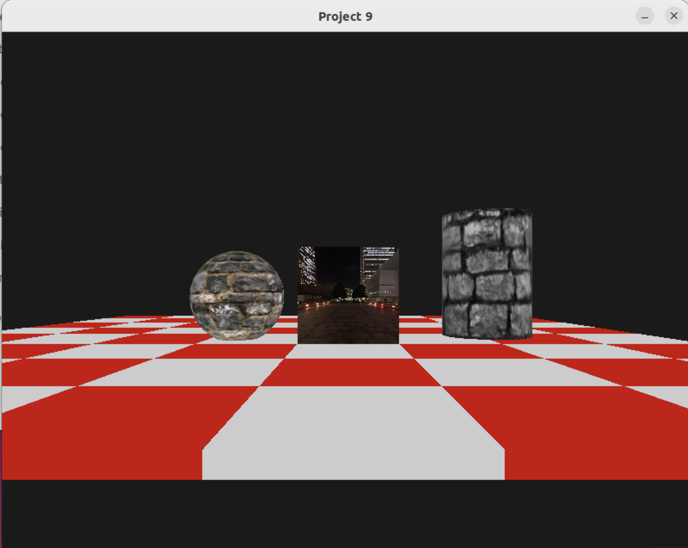

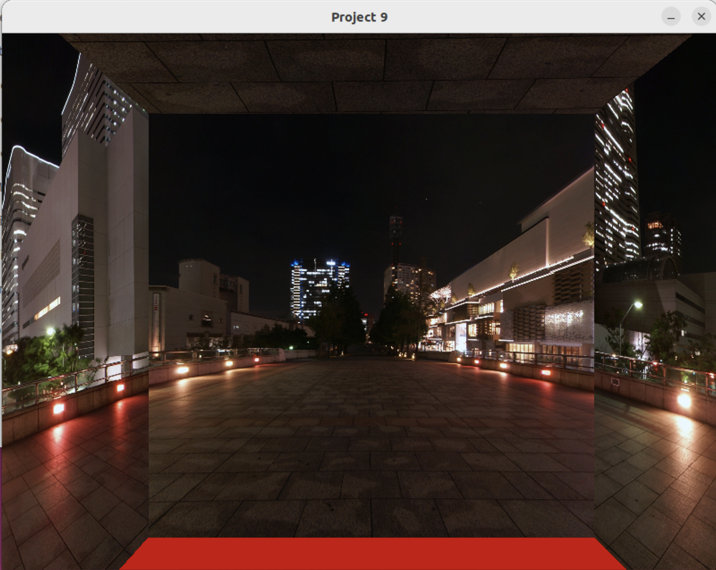

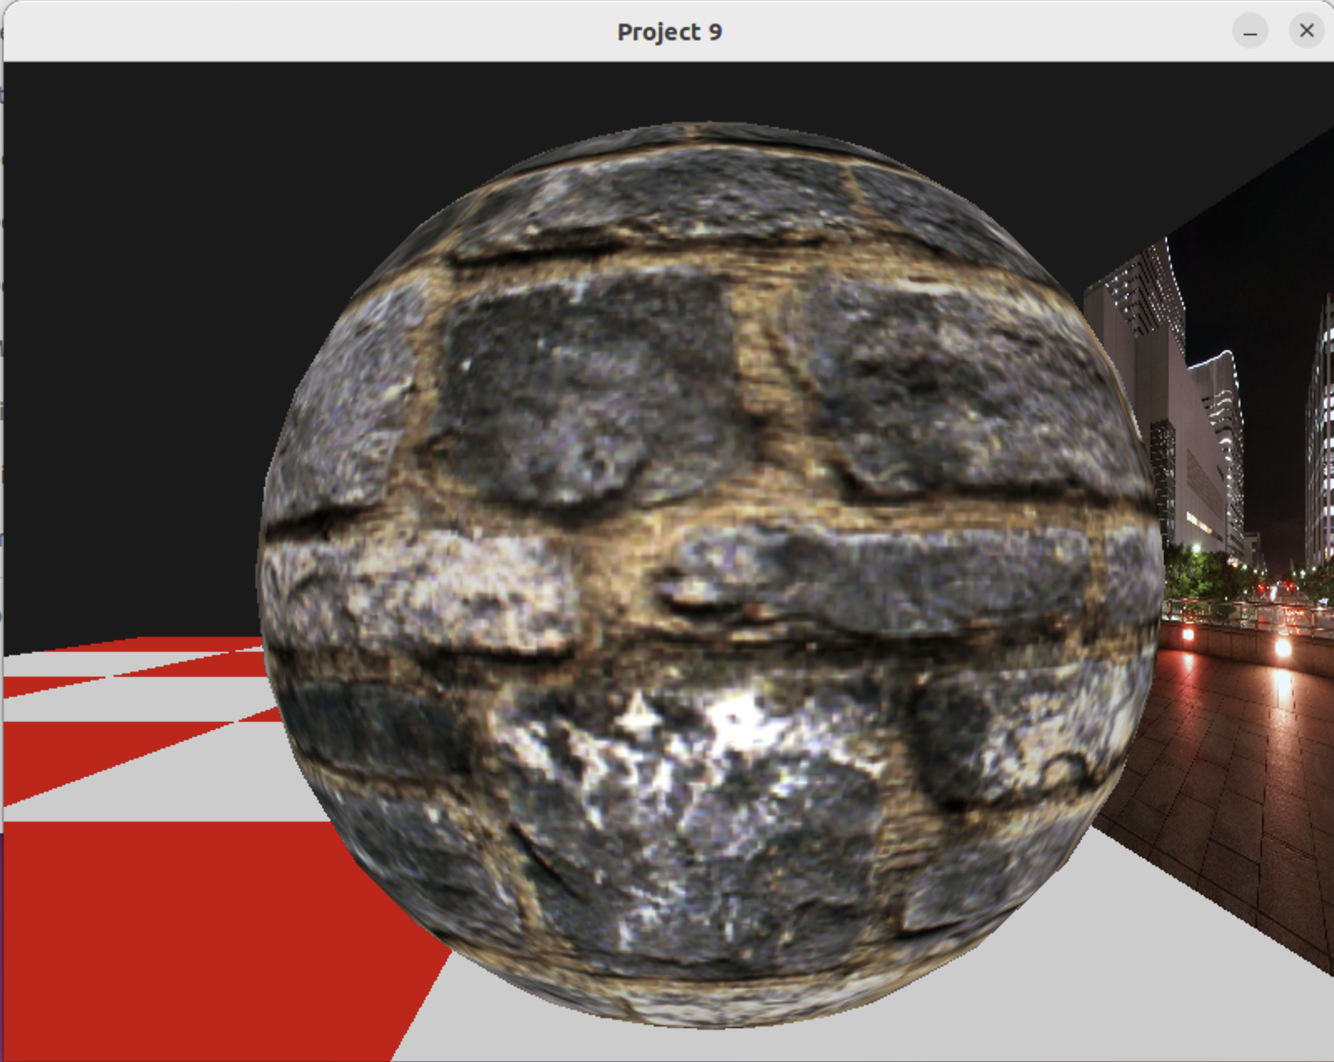

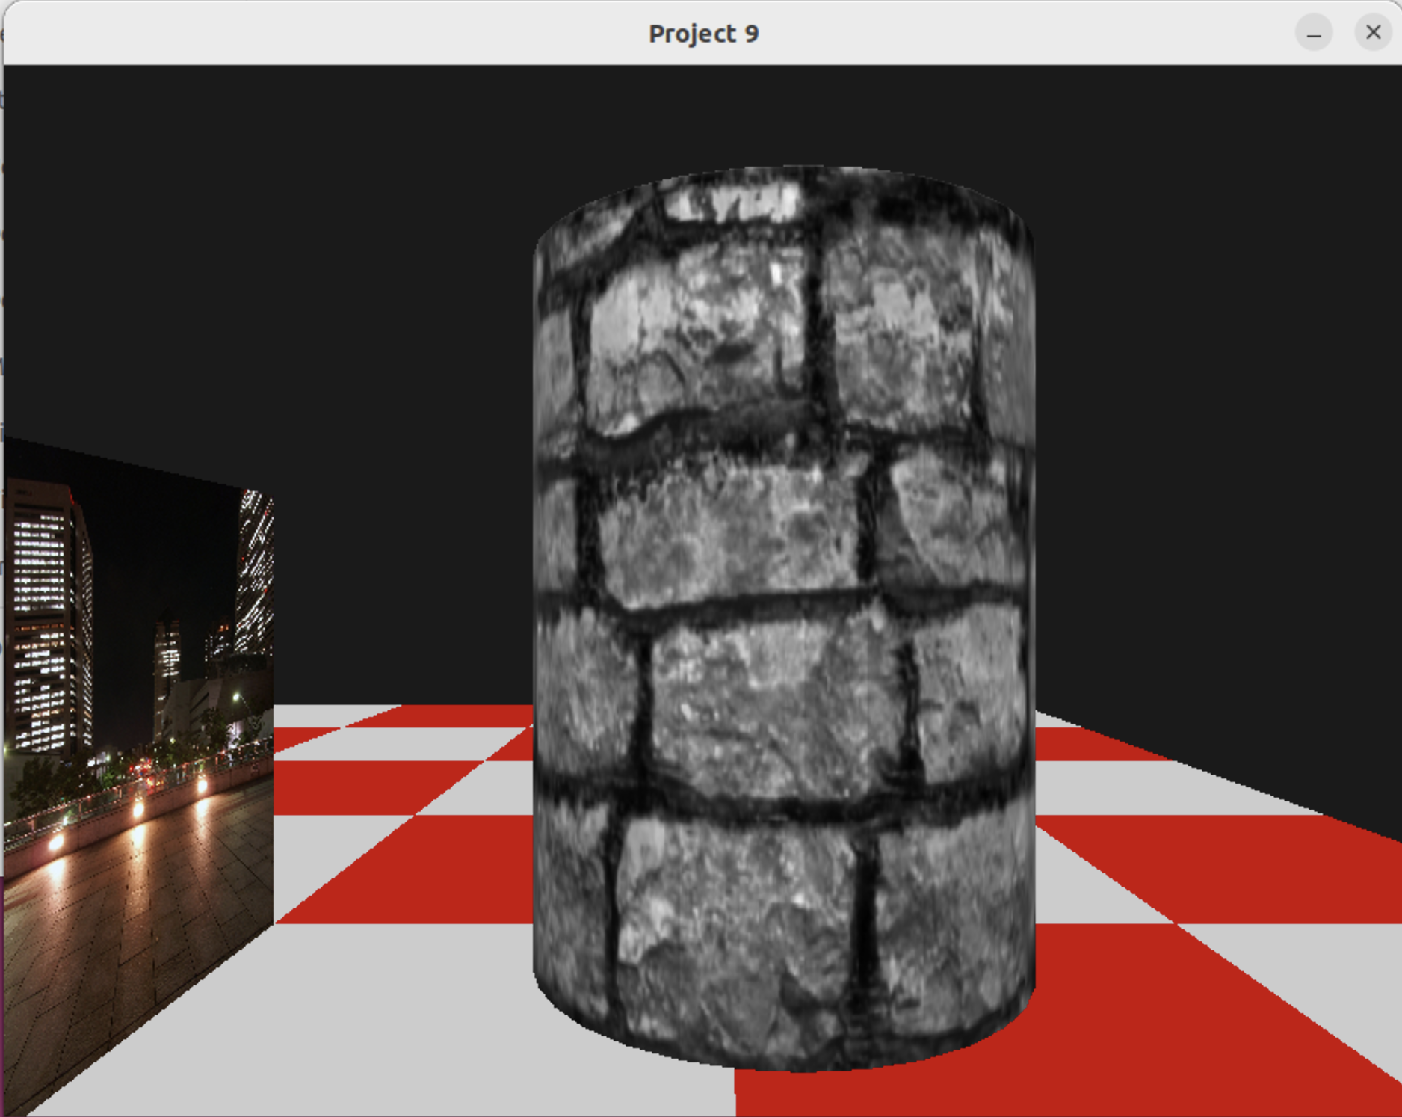

References

GLFW. (n.d.). *GLFW: An OpenGL library*. Retrieved from <https://www.glfw.org/>

*Textures*. Humus. (n.d.). https://www.humus.name/index.php?page=Textures&start=0

Wikimedia Foundation. (2024b, June 20). *Parallax mapping*. Wikipedia. https://en.wikipedia.org/wiki/Parallax_mapping